INTERNSHIP TASK REPORT

Embedded Systems & Internet of Things (IoT)

TASK-1: Introduction to Embedded Systems & IoT Device Design
Project: Motion Detection Alarm

Submitted To: MAINCRAFTS TECHNOLOGY

Submitted By: Name: M KASHI VISHWANATH
Role: Junior Embedded Engineer Intern
Date: 06-02-2026

https://www.maincrafts.com

1. Introduction to Embedded Systems

1.1 What is an Embedded System?
An embedded system is a computer system—comprising a combination of a computer processor, computer memory, and input/output peripheral devices—that has a dedicated function within a larger mechanical or electronic system. Unlike a general-purpose computer (like a laptop) that can perform many different tasks, an embedded system is engineered to perform a specific task, often with real-time computing constraints.

1.2 Real-World Applications
Embedded systems are ubiquitous in modern technology. Common applications include:
- Smart Home: Thermostats (like Nest), smart bulbs, and security cameras that automate home environments.
- Automotive: Anti-lock Braking Systems (ABS), airbag control systems, and engine management units (ECUs).
- Healthcare Devices: Pacemakers, digital blood pressure monitors, and MRI machines that require precise monitoring and control.
- Robotics: Industrial robots used in manufacturing lines and consumer drones used for photography or surveillance.

1.3 Microcontroller vs. Microprocessor
Feature | Microcontroller (MCU) | Microprocessor (MPU)
Definition | A small computer on a single integrated circuit (IC) containing a processor core, memory, and programmable I/O peripherals. | A computer processor that incorporates the functions of a central processing unit (CPU) on a single (or few) integrated circuits.
Components | CPU, RAM, ROM, and I/O ports are all embedded on a single chip. | CPU is standalone; RAM, ROM, and I/O ports are connected externally.
Cost & Power | Generally lower cost and lower power consumption. Ideal for battery-operated devices. | Higher cost and higher power consumption. Requires a more complex power supply.
Application | Used in specific, dedicated applications (e.g., washing machines, remote controls, alarm systems). | Used in general-purpose computing (e.g., laptops, smartphones, video game consoles).

2. Component Study

2.1 Microcontroller Comparison
In embedded system design, selecting the right processing unit is critical. Below is a comparison of three popular microcontrollers used in IoT prototypes.

Microcontroller | Role & Key Features | Best Use Case
Arduino UNO | A beginner-friendly board based on the ATmega328P chip. It focuses on simplicity with 5V logic, making it easy to interface with most basic sensors without extra components. | Learning basics, simple automation, and non-wireless projects.

2.2 Sensor Working Principles
Sensors act as the "eyes and ears" of an embedded system, converting physical environmental data into electrical signals.
Working Principle: PIR (Passive Infrared) Motion Sensor
The PIR sensor does not emit any energy (which is why it is called "Passive"); instead, it detects infrared energy emitted by other objects.
1. Infrared Radiation Detection
Every object with a temperature above absolute zero emits heat energy in the form of Infrared (IR) Radiation. While invisible to the human eye, this radiation is detected by the PIR sensor. Humans and animals, being warm-blooded, emit stronger IR radiation than inanimate objects like walls or chairs.
2. The Pyroelectric Sensor (The Internal Component)
Inside the sensor's metal can is a crystal material (pyroelectric sensor) that generates a small electrical charge when exposed to heat. This sensor is split into two rectangular slots.
Idle State: When the room is empty, both slots detect the same amount of ambient IR radiation (from walls/furniture). The signals cancel each other out, resulting in zero output.
Motion State: When a warm body (like a human) walks by, it intercepts the first slot, causing a positive differential change. As they continue walking, they leave the first slot and intercept the second slot, causing a negative differential change.

3. The Fresnel Lens (The White Dome)
The white plastic dome covering the sensor is a Fresnel Lens. It serves two purposes:
- Focusing: It condenses light and IR radiation from a wide area onto the tiny internal sensor.
- Zoning: It splits the room into "zones." As a person walks, they cross these zones, creating the rapid "hot-to-cold" changes that the sensor interprets as movement.
4. Signal Processing & Output
When the internal circuitry detects these rapid changes (pulses) between the two slots, it triggers the output pin:
Motion Detected: The Output Pin goes HIGH (3.3V - 5V). Your Arduino reads this and triggers the if (motionState == HIGH) block to sound the buzzer.
No Motion: The Output Pin remains LOW (0V).

"The Motion Detection Alarm uses a Passive Infrared (PIR) sensor to monitor the environment. The sensor works by detecting the differential change in infrared radiation levels caused by a warm body moving across its field of view. When the Fresnel lens focuses this moving heat signature onto the internal pyroelectric elements, the sensor generates a digital HIGH signal, which the Arduino processes to trigger the output alarm."

3. Project Details: Motion Detection Alarm

3.1 Project Objective
The objective of this project is to design and simulate a smart security system that detects unauthorized movement using a Passive Infrared (PIR) sensor. When motion is detected, the system triggers an audible alarm (Buzzer) and a visual warning (LED). This prototype demonstrates the fundamental principles of input/output interfacing in embedded systems.
3.2 Components Used
Microcontroller: Arduino UNO (Simulated) – The brain of the system.
Sensor: PIR (Passive Infrared) Motion Sensor – Detects heat signatures.
Actuators:
Piezo Buzzer – Generates sound.
Red LED – Visual indicator.
Resistor: 220Ω (Ohm) – To protect the LED.
3.3 Circuit Diagram & Connections
The circuit is connected as follows:
- PIR Sensor:
Signal Pin is connected to Arduino Digital Pin 2 (Input).
Power (VCC) and Ground (GND) are connected to the Arduino 5V and GND rails.
- Output Devices:
Buzzer: Positive leg connected to Digital Pin 12; Negative leg to GND.
LED: Anode (long leg) connected to Digital Pin 13 via a 220Ω resistor; Cathode (short leg) to GND.
3.4 Working Principle
The system operates in a continuous loop:
- Idle State: When the area is static, the PIR sensor output remains LOW (0V). The Arduino keeps the Buzzer and LED turned OFF.
- Detection: When a warm body (human/animal) moves across the sensor's field of view, the PIR sensor detects the differential change in infrared radiation.
- Trigger: The sensor sends a HIGH (5V) signal to Arduino Pin 2.
- Response: The Arduino code reads this HIGH signal and executes the alarm function, sending power to Pin 12 (Buzzer) and Pin 13 (LED) to alert the user.

3.5 Real-World Applications
This basic prototype is the foundation for many complex commercial systems:
Home Security Systems: Burglar alarms that notify homeowners or police of intruders.
Automated Lighting: Energy-saving systems in offices or corridors that turn lights on only when people are present.
Wildlife Monitoring: Camera traps that automatically photograph animals when they move in front of the lens.

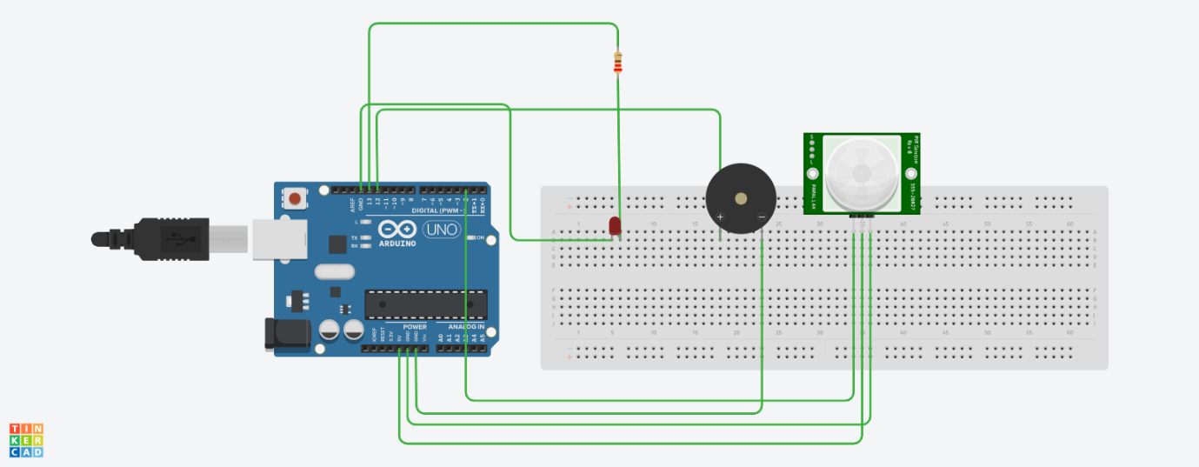
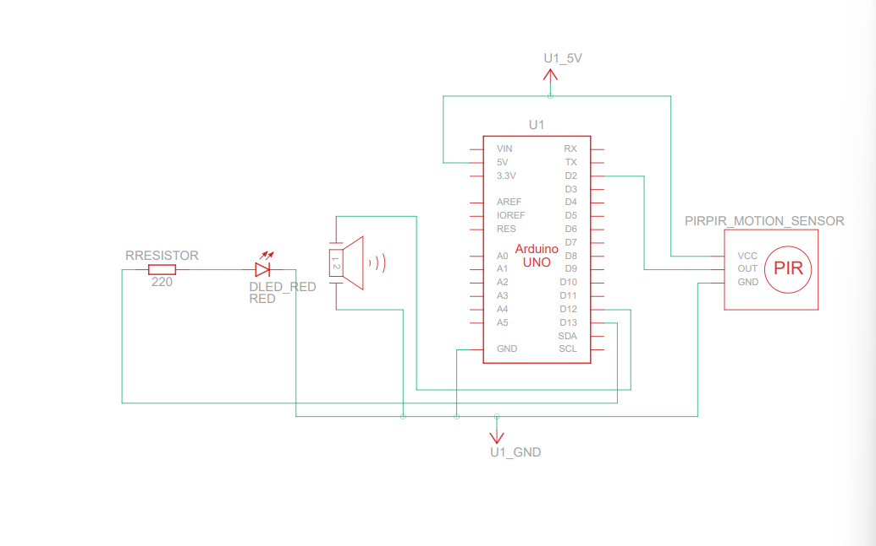

4 Source Code

* Project: Motion Detection Alarm
* Platform: Arduino UNO
* Description: Triggers LED and Buzzer when PIR sensor detects motion.

const int pirPin = 2;
const int buzzerPin = 12;
const int ledPin = 13;
int motionState = 0;
void setup() {
pinMode(pirPin, INPUT);
pinMode(buzzerPin, OUTPUT);
pinMode(ledPin, OUTPUT);
Serial.begin(9600);
}
void loop() {
motionState = digitalRead(pirPin);
if (motionState == HIGH) {
digitalWrite(buzzerPin, HIGH);
digitalWrite(ledPin, HIGH);
Serial.println("Motion Detected!");
}
else {
digitalWrite(buzzerPin, LOW);
digitalWrite(ledPin, LOW);
}
delay(100);
}

5 Conclusion

5.1 Summary of Learning
In this task, we explored the fundamental concepts of Embedded Systems and IoT device design. We learned that embedded systems are specialized computing units dedicated to specific tasks, distinct from general-purpose computers. Through the component study, we understood the critical differences between Microcontrollers (like Arduino) and Microprocessors, as well as the working principles of essential sensors like the PIR Motion Sensor.

5.2 Project Outcome
The practical implementation of the Motion Detection Alarm successfully demonstrated how hardware and software interact in an embedded environment. By interfacing a PIR sensor with an Arduino UNO, we created a functional prototype that processes real-world input (motion) to trigger immediate output (alarm and light). This simulation verified the logic required for building responsive security systems.

5.3 Future Scope
While this prototype serves as a foundational model, it can be expanded into a fully connected IoT device. Future improvements could include:
Wi-Fi Integration: Using an ESP32 to send mobile notifications when motion is detected.
Camera Module: Triggering an image capture to identify the intruder.
Data Logging: Storing the time and frequency of motion events for security analysis.

5.4 Project Working Video Link

https://drive.google.com/file/d/1evNRMH5j-DChyZrLUDt_xTqLf_d50OwH/view?usp=drive_link

--------------------------------------------------------------------------------------------------------------------------------------

Tank You

